**Lab 8: Android ListView Layout**

# **Introduction**

A view group called Android ListView collects various things and displays them in a vertical scrollable list. A list adapter, which draws content from a source like a database or an array, automatically inserts the list items.

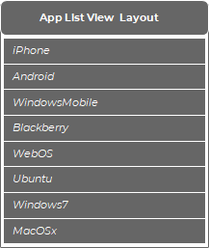

|  |  |
| --- | --- |
| Attribute | Description |
| id | Used to identify uniquely |
| divider | Used to separate items in list |
| dividerHeight | Used to specify the separator width of divider |
| entries | Used to control number of item in list in single screen |
| footerDividersEnabled | Has a Bool value to decide the visibility of footer divider |
| headerDividersEnabled | Has a Bool value to decide the visibility of header divider |

**Let’s get Started**

This exercise will take you through simple steps to show how to create your own Android application using ListView Layout.

**Step 1: Create a New Project in Android Studio as shown below**

**Step 2: Select Empty Activity as shown below**

**Step 3: Provide a Project Name as shown below**

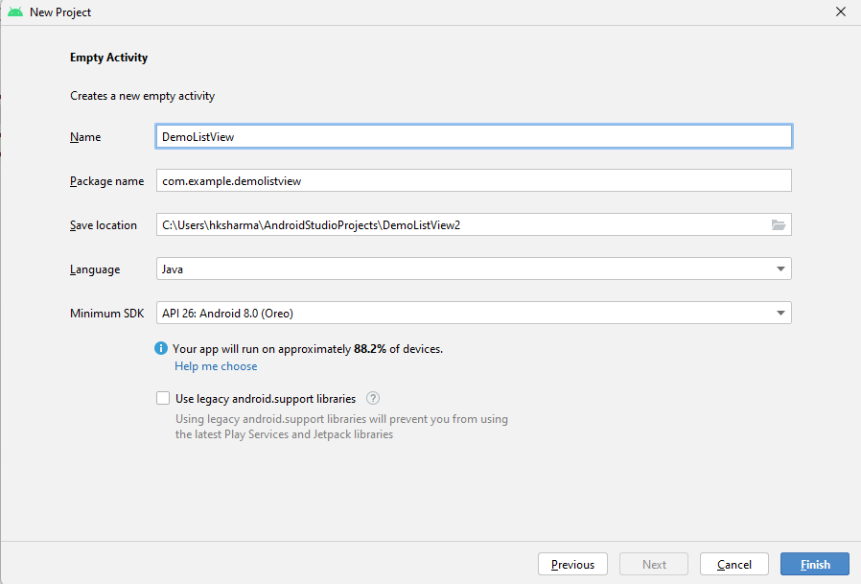

**Step 4: Update MainActivity.java as per the code given below**

**package** com.example.demolistview;  
**import** androidx.appcompat.app.AppCompatActivity;  
**import** android.os.Bundle;  
**import** android.view.View;  
**import** android.widget.AdapterView;  
**import** android.widget.ArrayAdapter;  
**import** android.widget.ListView;  
**import** android.widget.Toast;  
  
**import** java.util.ArrayList;  
  
**public class** MainActivity **extends** AppCompatActivity {  
 ArrayList<String> **alNames**= **new** ArrayList<>();  
  
 @Override  
 **protected void** onCreate(Bundle savedInstanceState) {  
 **super**.onCreate(savedInstanceState);  
 setContentView(R.layout.***activity_main***);  
 ListView lstView = findViewById(R.id.***lstView***);  
 **alNames**.add(**"Hitesh 1"**);  
 **alNames**.add(**"Hitesh 2"**);  
 **alNames**.add(**"Hitesh 3"**);  
 **alNames**.add(**"Hitesh 4"**);  
 **alNames**.add(**"Hitesh 5"**);  
 **alNames**.add(**"Hitesh 6"**);  
 **alNames**.add(**"Hitesh 7"**);  
 **alNames**.add(**"Hitesh 8"**);  
 **alNames**.add(**"Hitesh 9"**);  
 **alNames**.add(**"Hitesh 10"**);  
 ArrayAdapter<String> arrayAdapter= **new** ArrayAdapter<>(getApplicationContext(), android.R.layout.***simple_list_item_1***,**alNames**);  
 lstView.setAdapter(arrayAdapter);  
 lstView.setOnItemClickListener(**new** AdapterView.OnItemClickListener() {  
 @Override  
 **public void** onItemClick(AdapterView<?> adapterView, View view, **int** i, **long** l) {  
 **if** (i==0)  
 {  
 Toast.*makeText*(MainActivity.**this**, **"Clicked First Item"**, Toast.***LENGTH_SHORT***).show();  
 }  
 }  
 });  
  
 }  
}

**Step 5: Update activity_main.xml as per the code given below**

*<?***xml version="1.0" encoding="utf-8"***?>*<**LinearLayout  
 xmlns:android="http://schemas.android.com/apk/res/android"  
 xmlns:app="http://schemas.android.com/apk/res-auto"  
 xmlns:tools="http://schemas.android.com/tools"  
 android:layout_width="match_parent"  
 android:layout_height="match_parent"  
 tools:context=".MainActivity"**>  
  
  
 <**ListView  
 android:layout_width="match_parent"  
 android:layout_height="wrap_content"  
 android:id="@+id/lstView"**/>  
  
</**LinearLayout**>

**Step 6: Check Output on Android Emulator.**

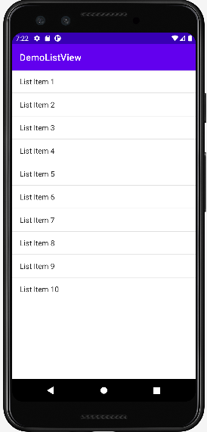 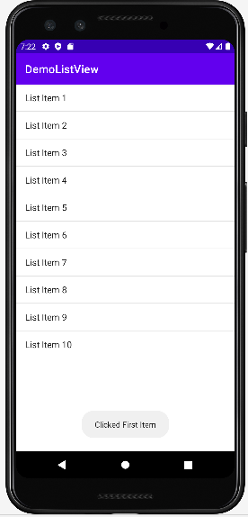

**Voila!!** We have successfully completed this lab.